**Assignment-4 (Plots & Correlation & Normal Distribution)**

**EXERCISE 1.**

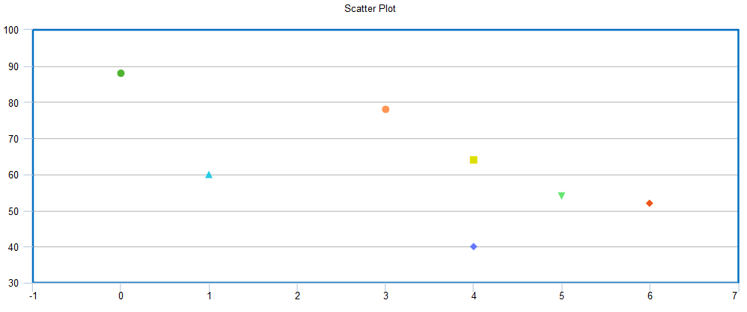

There is a negative strong (**Pearson’s correlation** is ( - 0.67367)) relationship between **X** and **Y**.

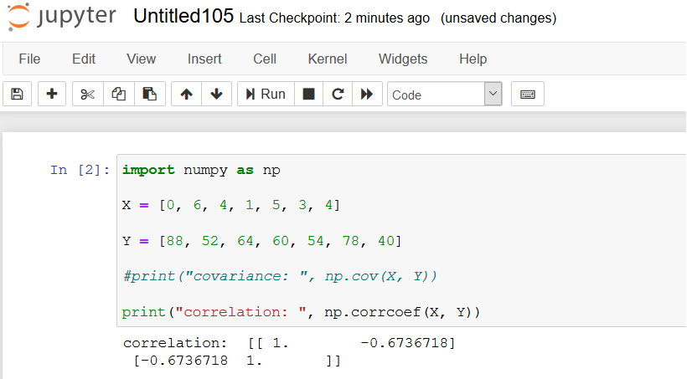

**EXERCISE 2.**

1. 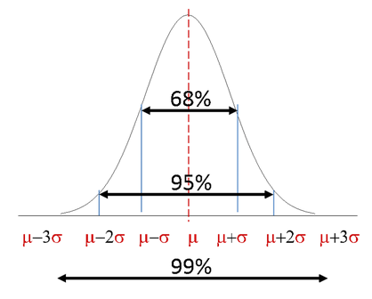

Considering the Normal Distribution figure above, {(%32)/2 = %16} of the students will be taller than 66.7 inches. The referred website also gives quite the same result (%15.87).

2.

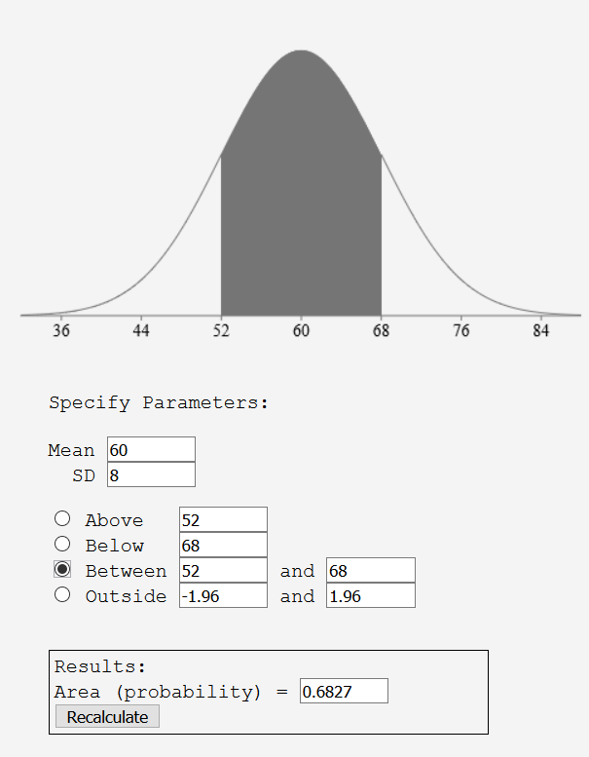

The question is the number of students between (mean – STD) and (mean+STD).

As can be seen from the figure above, result is % 68.27 of the students.

(300 * .06827) will be 204.81 or **204** students.

**EXERCISE 3**

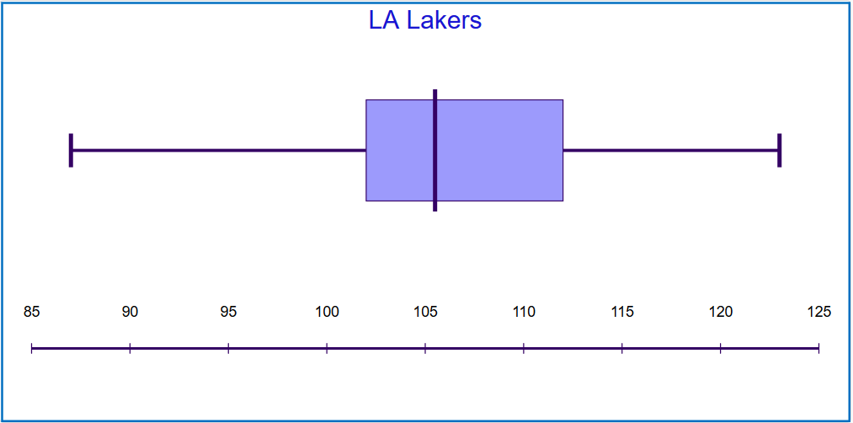

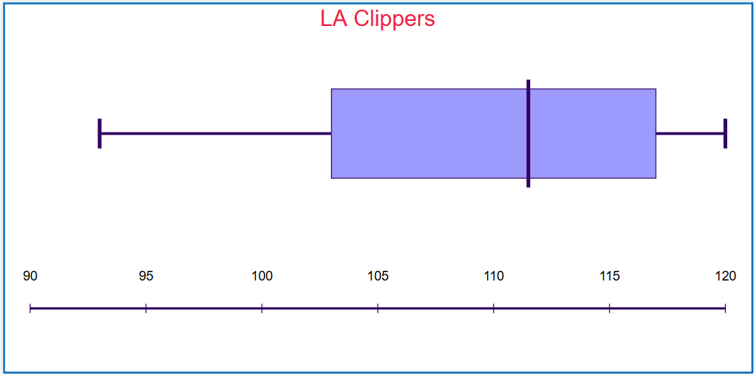

1. median (Lakers) = 105.4 median (Clippers) = 109.1

2. Lakers’ IQR = 10 Clippers’ IQR = 5.5

3. Clippers won 6 games with a score above the team’s median (60%).

Lakers won 5 games with a score above the team’s median (50%).